**TASK – 19**

**Creating EC2 instance:**

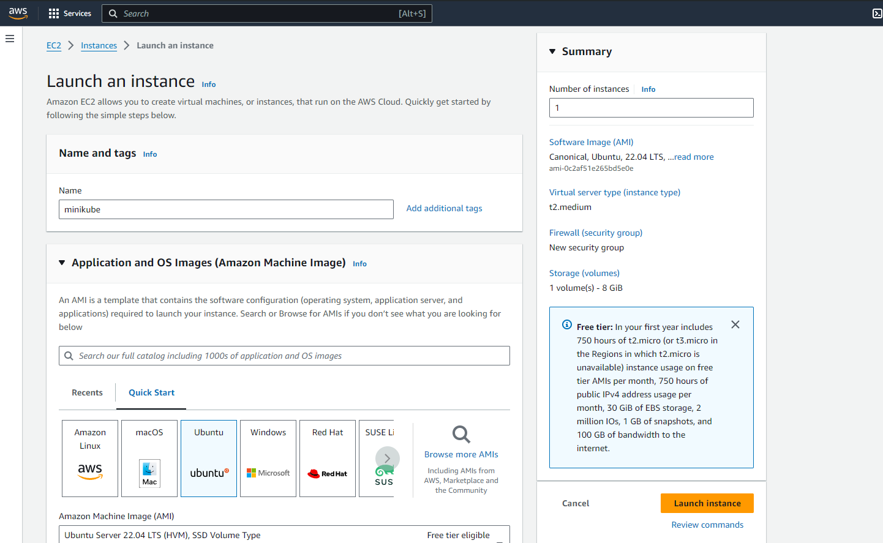

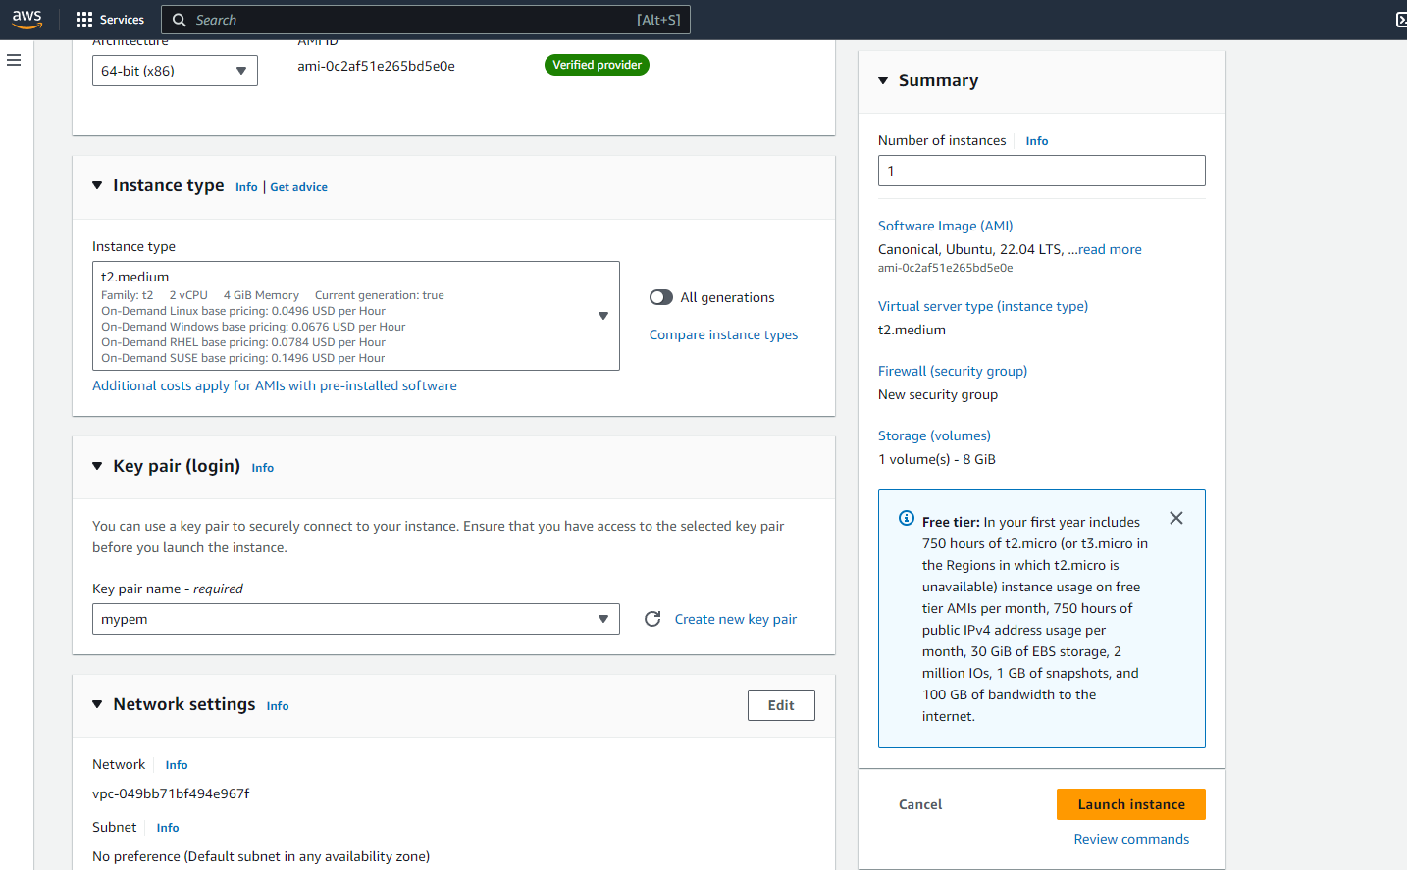

**Installing docker:**

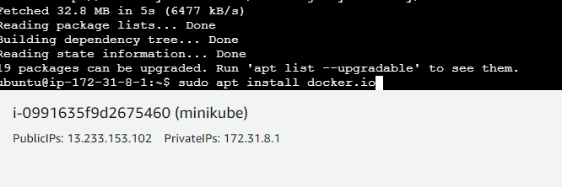

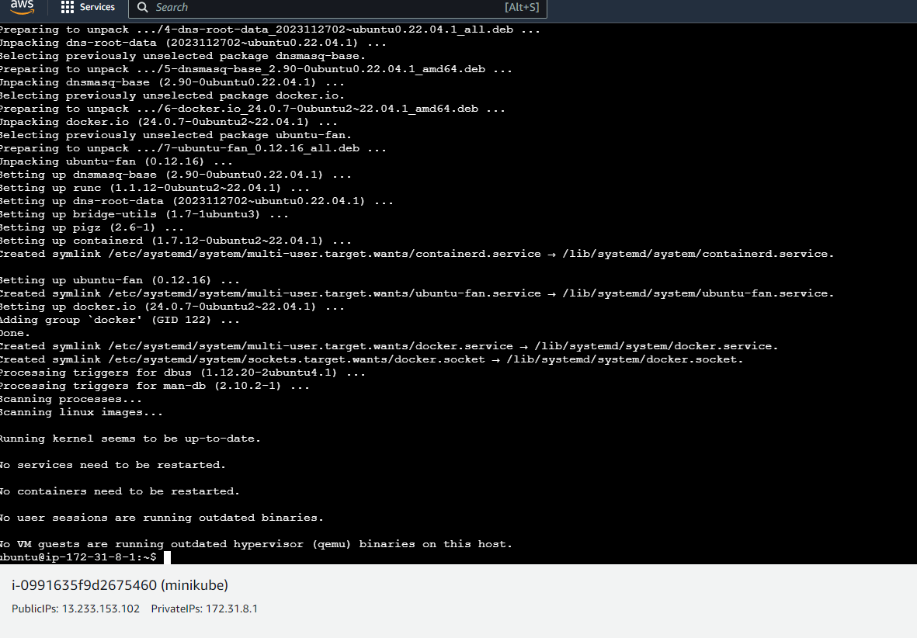

**Installing minikube:**

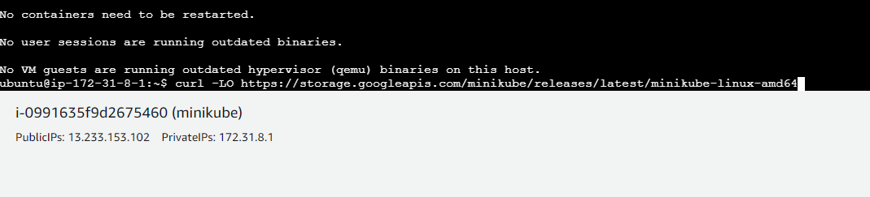

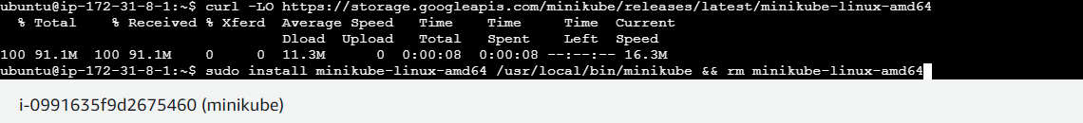



**Installing kubectl:**

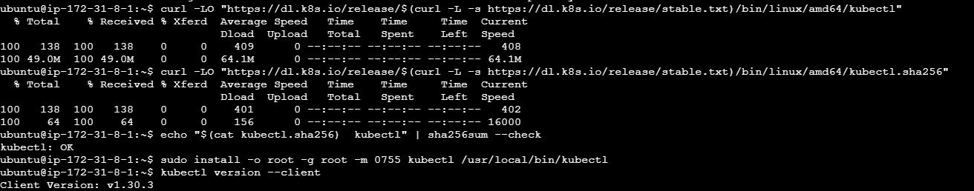

**Creating a new namespace:**



**Viewing created namespace:**

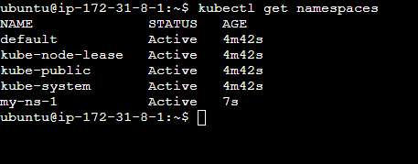

**Creating a pod with the namespace:**

